GROUP 20 29TH September 2010
SM/SMS/10/0027
EXPERIMENT 1
DETERMINATION OF MODULUS OF ELASTICITY
AIM: To determine the modulus of elasticity by applying Hooke’s law.
APPARATUS: Dial gauge, Holder for dial gauge, flat metal bar, knife edge with stirrup, and bolt with knife edge, weight holder for slotted weights, tripod base, support rod, right angle clamp, slotted weights 50g and meter rule.
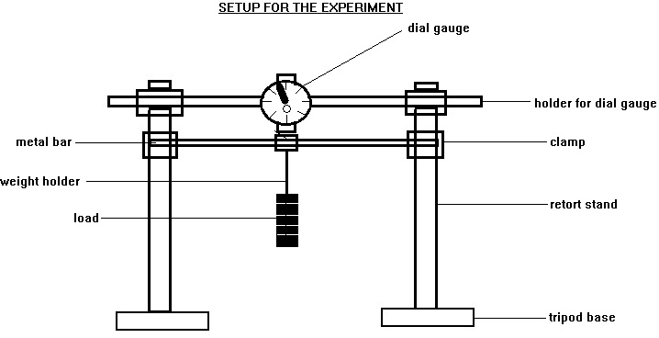
METHOD: The dial gauge was mounted on the knife edge with a stir up. The height (b), width (a) and length of the metal bar were measured several times. The metal was then placed on the two knife edges with precision such that movement in the x and y directions were not restricted but allowed. The metal bar was positioned in a manner that the length between the two knife edges was 45cm. The metal bar, weighed down with 250g of the masses was centered between the knife edges. The dial gauge had a dynamometer and a plunger which showed full deflection. The plunger was raised and lowered gently to set the dial to zero .The weights were then mounted and reduced by 50g and its dial readings were observed and recorded.
THEORY: An elastic modulus or modulus of elasticity is the mathematical description of an object or substance’s tendency to be deformed elastically (that is non-permanently) when a force is applied to it. According to young modulus, when a force or tension, F is applied to the end of a wire of cross sectional area (A), then tensile stress = $\frac{F}{A}$. Also, if the extension of the wire is, e and the initial length is l₀, then the tensile strength= $\frac{e}{l_{0}}$. From Hooke’s law which states, provided the elastic limit of a material is not exceeded, the extension is directly proportional to the applied force.
$\frac{F}{A}$ is directly proportional to$\frac{e}{l_{0}}$ (because A and l₀ are constants).
$\frac{F}{A}$ = K$\frac{e}{l_{0}}$ where K is the constant of proportionality. K is called young’s modulus of elasticity (E). Therefore K = E
$\frac{F}{A}$ = e $\left(\frac{E}{l_{0}}\right)$
E = $\frac{F}{A}$ x $\frac{l_{0}}{e}$ Also, F = e $\left(\frac{EA}{l_{0}}\right)$
E = $\left(\frac{Fl_{0}}{Ae}\right)$
TABLE OF RESULTS
Length of metal bar- 50.5 cm Dial gauge= 0.1mm
Height of metal bar- 0.1cm Width of metal bar- 2 cm
Mass/g | Force/N | e₁/cm | e₂/cm | e₃/cm | e₄/cm | e₅/cm | e_{av}/cm
250 | 2.5 | 32.5 | 32.3 | 32.6 | 32.7 | 32.4 | 32.50
200 | 2.0 | 26.5 | 26.8 | 26.4 | 26.4 | 26.2 | 26.46
150 | 1.5 | 18.6 | 18.4 | 18.9 | 18.2 | 18.5 | 18.52
100 | 1.0 | 11.9 | 12.1 | 12.4 | 11.8 | 12.0 | 12.04
50 | 0.5 | 5.9 | 5.5 | 6.1 | 6.2 | 6.0 | 5.94

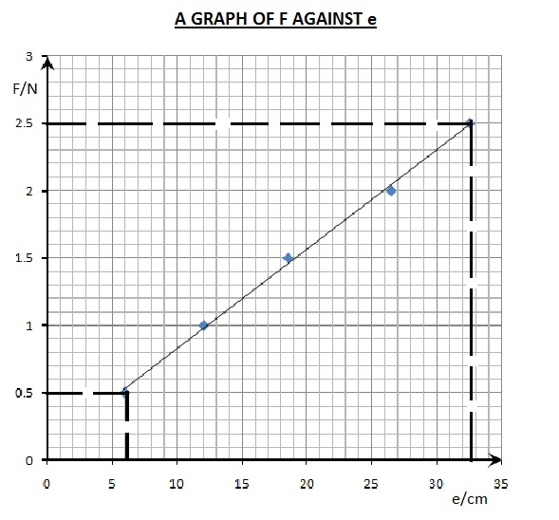

CALCULATION: Length of metal bar- 50.5 cm = 0.505 m
Height of metal bar- 0.1cm = 0.001 m
Width of metal bar- 2 cm = 0.02 m
Cross sectional area of metal bar (A) = width x height
= 0.001m x 0.02m
= 2 x 10⁻⁵ m
Slope of graph = $\frac{F}{e}$ = $\frac{2.5N-0.5N}{0.0325m-0.059m}$ = $\frac{2N}{0.266m}$
= 7.519 N/m
From the equation of the graph y = 7.519x, the slope of the graph is 7.519.Using the Young’s modulus of elasticity equation E = $\frac{FL}{Ae}$ (but $\frac{F}{e}$ is equal to the slope)
E = $\frac{7.519 x L}{A}$ = $\frac{7.519N/m x 0.505m}{2 x {10}^{-5}m^{2}}$
E = $\frac{3.797N}{2 x {10}^{-5}m^{2}}$ = 189854.8 Nm⁻²
Discussion: The graph of force/N against e/m is a straight line graph passing through the origin. The equation of the graph is y=7.519x. From this equation, the slope is 7.519 by comparing to the equation of a line (that is y=mx+c where c=intercept = 0). The modulus of elasticity of the metal rod is found to be 189854.8 Nm⁻². From the table, as force decrease, the extension also decreases. This means that the extension is directly proportional to the force (F α e). For example, from the table, when the force is 2.5N, the average extension is found to be 32.50 cm. Again, when the force decreased to 2.0N by unloading 50g of the mass, the average extension decreased to 26.46 cm. It is possible that the calculated modulus of elasticity is not the actual value of the metal due to the fact that the ruler was not accurately calibrated which affected the measurement of the length of the metal bar.

ERRORS:
1) Errors might be due to the fact that the ruler was not accurately calibrated which affected the measurement of the length of the metal bar.
2) Errors might be due to the fact that readings were not taken at the eye level and that resulted in parallax errors.

PRECAUTIONS:
1) It was ensured that the bars were positioned accurately on the two supporting knife edges so that they could move in the x and y directions.
2) The readings were repeated and their averages taken or recorded in order to avoid random error.

CONCLUSIONS: The equation of the graph is y=7.519x therefore the slope of the graph is 7.519. From the calculation, the modulus of elasticity of the metal bar was found to be 189854.8 Nm⁻².$269438.8153Nm^{-2}$
Reference:
SERWAY A. Raymond, Faughn S. J. (2005) College physics. Thomson Learning Inc. USA. Page 258.

